

*Национальный исследовательский университет ИТМО   
(Университет ИТМО)*

*Факультет систем управления и робототехники*

Дисциплина: Дискретная математика

**Отчет по заданиям для закрытия академической разницы**

Вариант 4

Студент:

*Евстигнеев Дмитрий*

Группа: *R3242*

Преподаватель:

*Халимон Виктория Ивановна*

Санкт-Петербург

2021

**Пятое задание.**

1. **(a˅(⌐(b*c*d)))*(⌐(a*c))**

Таблица истинности

|  |  |  |  |  |  |  |  |  |  |  |
| --- | --- | --- | --- | --- | --- | --- | --- | --- | --- | --- |
| a | b | c | d | b&c | (b&c)&d | ⌐((b&c)&d) | av(⌐((b&c)&d)) | a&c | ⌐(a&c) | (av(⌐((b&c)&d)))&(⌐(a&c)) |
| 0 | 0 | 0 | 0 | 0 | 0 | 1 | 1 | 0 | 1 | 1 |
| 0 | 0 | 0 | 1 | 0 | 0 | 1 | 1 | 0 | 1 | 1 |
| 0 | 0 | 1 | 0 | 0 | 0 | 1 | 1 | 0 | 1 | 1 |
| 0 | 0 | 1 | 1 | 0 | 0 | 1 | 1 | 0 | 1 | 1 |
| 0 | 1 | 0 | 0 | 0 | 0 | 1 | 1 | 0 | 1 | 1 |
| 0 | 1 | 0 | 1 | 0 | 0 | 1 | 1 | 0 | 1 | 1 |
| 0 | 1 | 1 | 0 | 1 | 0 | 1 | 1 | 0 | 1 | 1 |
| 0 | 1 | 1 | 1 | 1 | 1 | 0 | 0 | 0 | 1 | 0 |
| 1 | 0 | 0 | 0 | 0 | 0 | 1 | 1 | 0 | 1 | 1 |
| 1 | 0 | 0 | 1 | 0 | 0 | 1 | 1 | 0 | 1 | 1 |
| 1 | 0 | 1 | 0 | 0 | 0 | 1 | 1 | 1 | 0 | 0 |
| 1 | 0 | 1 | 1 | 0 | 0 | 1 | 1 | 1 | 0 | 0 |
| 1 | 1 | 0 | 0 | 0 | 0 | 1 | 1 | 0 | 1 | 1 |
| 1 | 1 | 0 | 1 | 0 | 0 | 1 | 1 | 0 | 1 | 1 |
| 1 | 1 | 1 | 0 | 1 | 0 | 1 | 1 | 1 | 0 | 0 |
| 1 | 1 | 1 | 1 | 1 | 1 | 0 | 1 | 1 | 0 | 0 |

Упрощенное логическое выражение: 

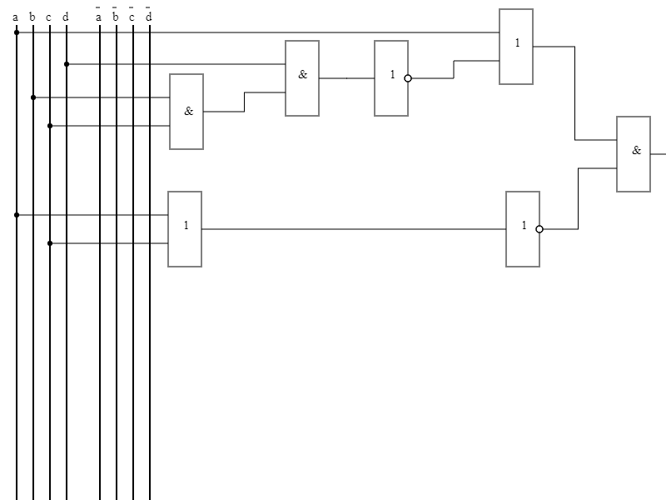

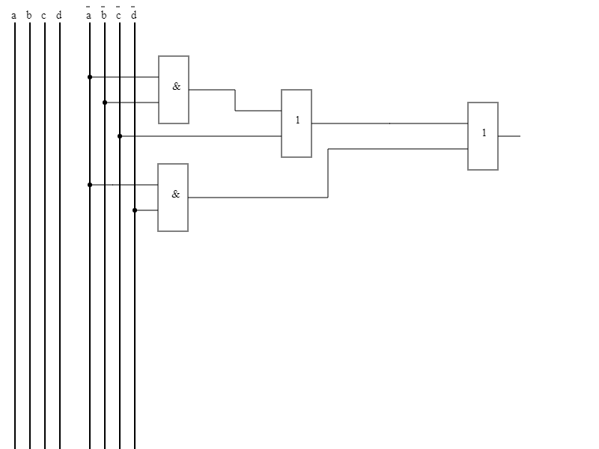

1. **((a*⌐(b))˅c)*((⌐(a)˅b)˅⌐(c))**  
   Таблица истинности

|  |  |  |  |  |  |  |  |  |  |  |
| --- | --- | --- | --- | --- | --- | --- | --- | --- | --- | --- |
| a | b | c | ⌐b | a&(⌐b) | (a&(⌐b))vc | ⌐a | (⌐a)vb | ⌐c | ((⌐a)vb)v(⌐c) | ((a&(⌐b))vc)&(((⌐a)vb)v(⌐c)) |
| 0 | 0 | 0 | 1 | 0 | 0 | 1 | 1 | 1 | 1 | 0 |
| 0 | 0 | 1 | 1 | 0 | 1 | 1 | 1 | 0 | 1 | 1 |
| 0 | 1 | 0 | 0 | 0 | 0 | 1 | 1 | 1 | 1 | 0 |
| 0 | 1 | 1 | 0 | 0 | 1 | 1 | 1 | 0 | 1 | 1 |
| 1 | 0 | 0 | 1 | 1 | 1 | 0 | 0 | 1 | 1 | 1 |
| 1 | 0 | 1 | 1 | 1 | 1 | 0 | 0 | 0 | 0 | 0 |
| 1 | 1 | 0 | 0 | 0 | 0 | 0 | 1 | 1 | 1 | 0 |
| 1 | 1 | 1 | 0 | 0 | 1 | 0 | 1 | 0 | 1 | 1 |

Упрощенное логическое выражение: 

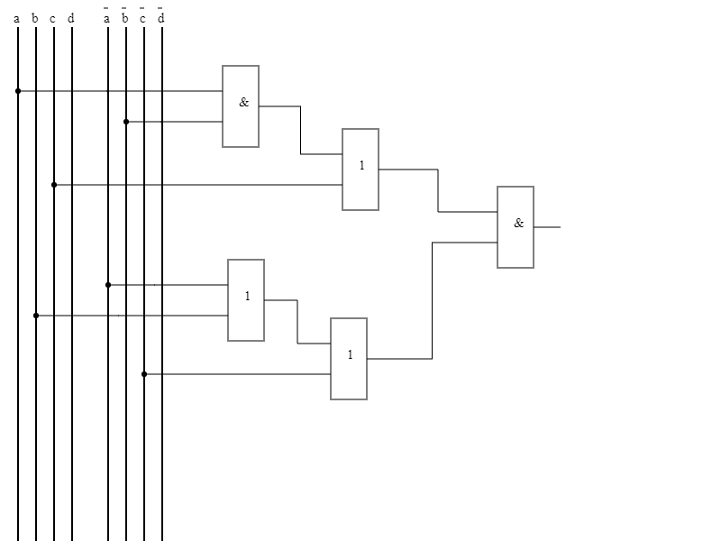

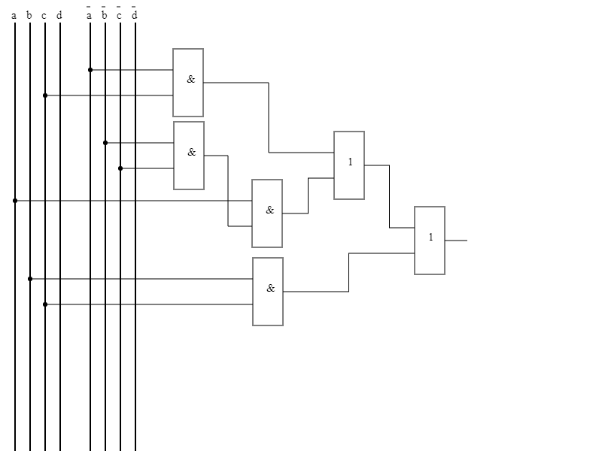

**Шестое задание.**

1. **a*b*(c˅d)˅⌐(b*c*d)˅a*b*c**

Таблица истинности

|  |  |  |  |  |  |  |  |  |  |  |  |  |
| --- | --- | --- | --- | --- | --- | --- | --- | --- | --- | --- | --- | --- |
| a | b | c | d | a&b | cvd | (a&b)&(cvd) | b&c | (b&c)&d | ⌐((b&c)&d) | ((a&b)&(cvd))v(⌐((b&c)&d)) | (a&b)&c | (((a&b)&(cvd))v(⌐((b&c)&d)))v((a&b)&c) |
| 0 | 0 | 0 | 0 | 0 | 0 | 0 | 0 | 0 | 1 | 1 | 0 | 1 |
| 0 | 0 | 0 | 1 | 0 | 1 | 0 | 0 | 0 | 1 | 1 | 0 | 1 |
| 0 | 0 | 1 | 0 | 0 | 1 | 0 | 0 | 0 | 1 | 1 | 0 | 1 |
| 0 | 0 | 1 | 1 | 0 | 1 | 0 | 0 | 0 | 1 | 1 | 0 | 1 |
| 0 | 1 | 0 | 0 | 0 | 0 | 0 | 0 | 0 | 1 | 1 | 0 | 1 |
| 0 | 1 | 0 | 1 | 0 | 1 | 0 | 0 | 0 | 1 | 1 | 0 | 1 |
| 0 | 1 | 1 | 0 | 0 | 1 | 0 | 1 | 0 | 1 | 1 | 0 | 1 |
| 0 | 1 | 1 | 1 | 0 | 1 | 0 | 1 | 1 | 0 | 0 | 0 | 0 |
| 1 | 0 | 0 | 0 | 0 | 0 | 0 | 0 | 0 | 1 | 1 | 0 | 1 |
| 1 | 0 | 0 | 1 | 0 | 1 | 0 | 0 | 0 | 1 | 1 | 0 | 1 |
| 1 | 0 | 1 | 0 | 0 | 1 | 0 | 0 | 0 | 1 | 1 | 0 | 1 |
| 1 | 0 | 1 | 1 | 0 | 1 | 0 | 0 | 0 | 1 | 1 | 0 | 1 |
| 1 | 1 | 0 | 0 | 1 | 0 | 0 | 0 | 0 | 1 | 1 | 0 | 1 |
| 1 | 1 | 0 | 1 | 1 | 1 | 1 | 0 | 0 | 1 | 1 | 0 | 1 |
| 1 | 1 | 1 | 0 | 1 | 1 | 1 | 1 | 0 | 1 | 1 | 1 | 1 |
| 1 | 1 | 1 | 1 | 1 | 1 | 1 | 1 | 1 | 0 | 1 | 1 | 1 |

Минимизированное логическое выражение: 

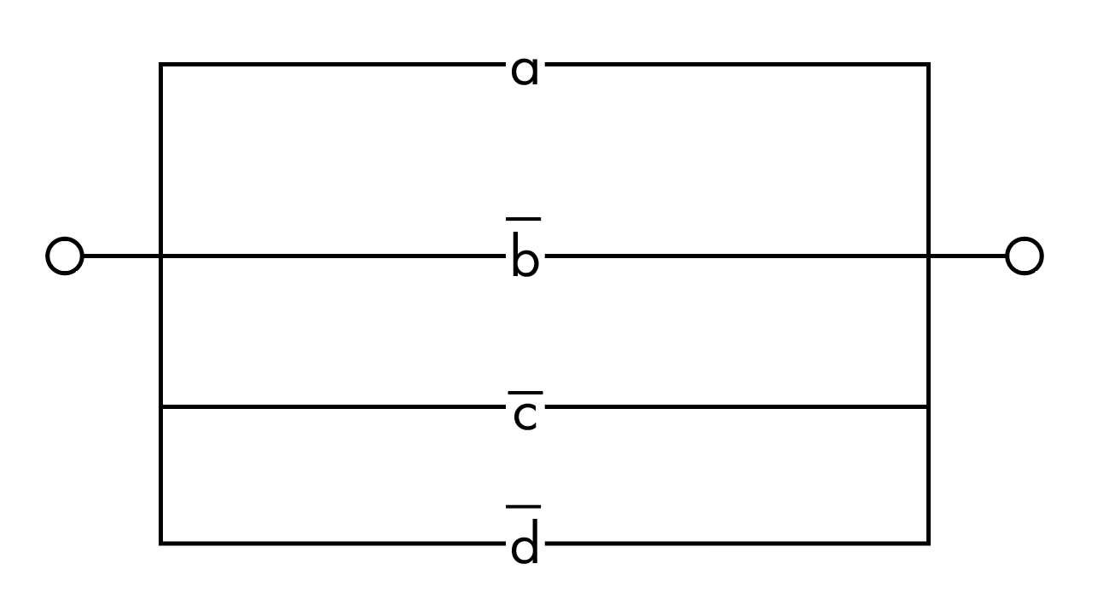

1. **(a*⌐(b)*⌐(a))˅(c*⌐(a))˅⌐(c*b)˅c**

Таблица истинности

|  |  |  |  |  |  |  |  |  |  |  |  |  |
| --- | --- | --- | --- | --- | --- | --- | --- | --- | --- | --- | --- | --- |
| a | b | c | ⌐b | a&(⌐b) | ⌐a | (a&(⌐b))&(⌐a) | c&(⌐a) | ((a&(⌐b))&(⌐a))v(c&(⌐a)) | c&b | ⌐(c&b) | (((a&(⌐b))&(⌐a))v(c&(⌐a)))v(⌐(c&b)) | ((((a&(⌐b))&(⌐a))v(c&(⌐a)))v(⌐(c&b)))vc |
| 0 | 0 | 0 | 1 | 0 | 1 | 0 | 0 | 0 | 0 | 1 | 1 | 1 |
| 0 | 0 | 1 | 1 | 0 | 1 | 0 | 1 | 1 | 0 | 1 | 1 | 1 |
| 0 | 1 | 0 | 0 | 0 | 1 | 0 | 0 | 0 | 0 | 1 | 1 | 1 |
| 0 | 1 | 1 | 0 | 0 | 1 | 0 | 1 | 1 | 1 | 0 | 1 | 1 |
| 1 | 0 | 0 | 1 | 1 | 0 | 0 | 0 | 0 | 0 | 1 | 1 | 1 |
| 1 | 0 | 1 | 1 | 1 | 0 | 0 | 0 | 0 | 0 | 1 | 1 | 1 |
| 1 | 1 | 0 | 0 | 0 | 0 | 0 | 0 | 0 | 0 | 1 | 1 | 1 |
| 1 | 1 | 1 | 0 | 0 | 0 | 0 | 0 | 0 | 1 | 0 | 0 | 1 |

Минимизированное логическое выражение:  = 1

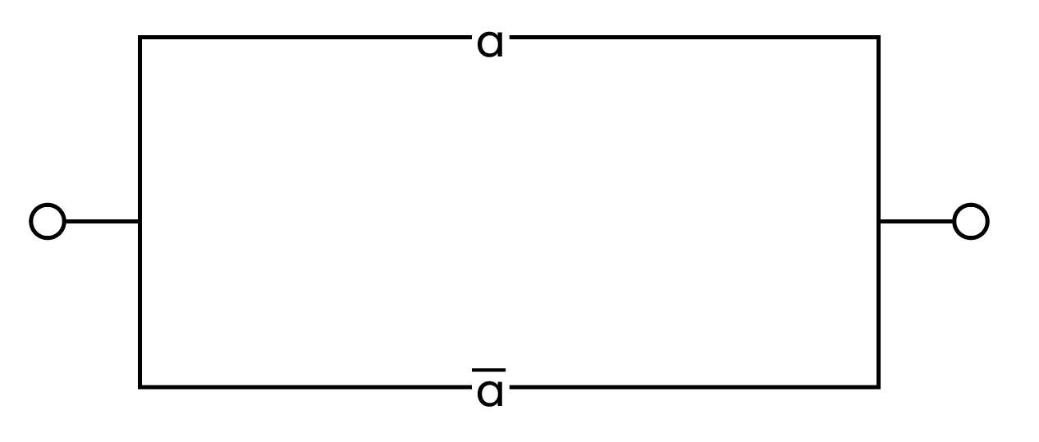

**Или**

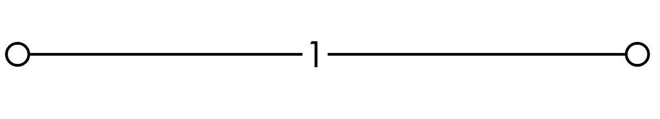

1. **((a*⌐(b))˅c)*(⌐(a˅b)˅⌐(c))**

Таблица истинности

|  |  |  |  |  |  |  |  |  |  |  |  |
| --- | --- | --- | --- | --- | --- | --- | --- | --- | --- | --- | --- |
| a | b | c | ⌐b | a&(⌐b) | (a&(⌐b))vc | ⌐((a&(⌐b))vc) | avb | ⌐(avb) | ⌐c | (⌐(avb))v(⌐c) | (⌐((a&(⌐b))vc))&((⌐(avb))v(⌐c)) |
| 0 | 0 | 0 | 1 | 0 | 0 | 1 | 0 | 1 | 1 | 1 | 1 |
| 0 | 0 | 1 | 1 | 0 | 1 | 0 | 0 | 1 | 0 | 1 | 0 |
| 0 | 1 | 0 | 0 | 0 | 0 | 1 | 1 | 0 | 1 | 1 | 1 |
| 0 | 1 | 1 | 0 | 0 | 1 | 0 | 1 | 0 | 0 | 0 | 0 |
| 1 | 0 | 0 | 1 | 1 | 1 | 0 | 1 | 0 | 1 | 1 | 0 |
| 1 | 0 | 1 | 1 | 1 | 1 | 0 | 1 | 0 | 0 | 0 | 0 |
| 1 | 1 | 0 | 0 | 0 | 0 | 1 | 1 | 0 | 1 | 1 | 1 |
| 1 | 1 | 1 | 0 | 0 | 1 | 0 | 1 | 0 | 0 | 0 | 0 |

Минимизированное логическое выражение: 

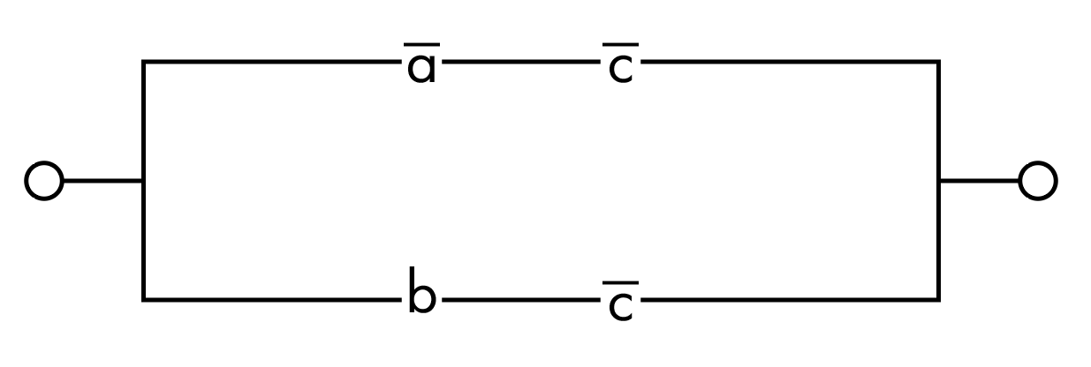

**Седьмое задание.**

1. **(⌐x1˅⌐x2)*x3=y1**

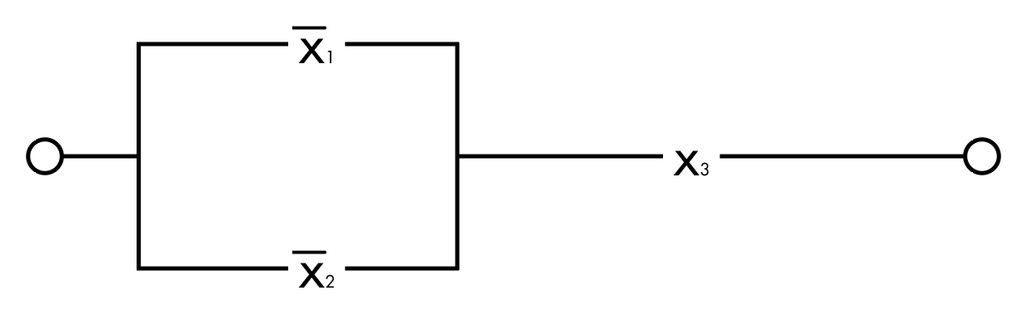

1. **(x3 NOR x2)*x1=y2**

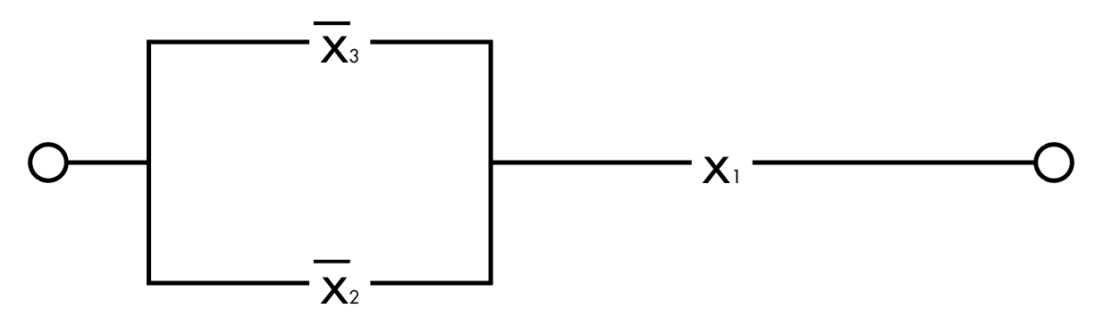

1. **(A*B)* ⌐A*(⌐B*⌐C)=0**

